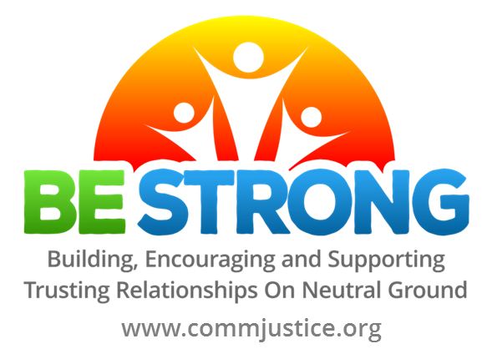
Resources
Websites
https://www.restorative.ca/ Restorative Practice Consortium (Based in Ontario – collaboration of educators and school boards in South Western / Central Ontario)
http://relationshipsfirstnl.com/ Relationships First: Restorative Justice in Education
http://edpolicy.education.jhu.edu/?p=1561 Restorative Practices in Schools – Johns Hopkins University
https://www.ousd.org/restorativejustice Oakland Unified School District – many OUSD schools have embraced restorative justice as a means of building inclusive caring and safe learning communities. A resource rich site.
https://sites.google.com/a/ousd.k12.ca.us/ousd-rj-resources/ OUSD resources, trouble-shooting ideas and templates.
http://ednextgen.com/ Education Next Generation Online Conference)
http://peacealliance.org/teachpeace/ Restorative Practices in schools
http://www.prevnet.ca/ Promoting Relationships and Eliminating Violence Network (A good Canadian resource for information about bullying and bullying prevention.)
https://www.cnvc.org/ NVC – Non Violent Communication
http://canada.iirp.edu/ International Institute for Restorative Practices
http://livingjusticepress.org Living Justice Press
http://mindfulschools.org/ mindfulness practices for teachers
Resources
Guides (Electronic .pdf documents supporting theory in practice)
Restorative Practice Resource Project Restorative Practice Consortium (Ontario, 2017)
Teaching Restorative Practices with Classroom Circles Amos Clifford (San Francisco Unified School District)
Oakland Unified School District Restorative Justice Implementation Guide: A Whole School Approach
San Francisco Unified School District Restorative Practices Whole School Implementation Guide
Books
1. The Little Book of Restorative Justice in Education, Katherine Evans & Dorothy Vaandering
2. Circle Forward: Building a Restorative School Community, Carolyn Boyes-Watson & Kay Pranis
3. The Restorative Practices Handbook: for Teachers, Disciplinarians and Administrators, Bob Costello, Joshua Wachtel and Ted Wachtel
4. Restorative Circles in Schools: Building Community and Enhancing Learning, Bob Costello, Joshua Wachtel and Ted Wachtel
5. Restorative Theory in Practice: Insights into what works and why, Belinda Hopkins, Ed. *excellent overview on why restorative approaches are effective
6. Empowering Voices for Student Success: Embedding Restorative Practice and Circle Process in School Culture, Catherine Wills and Lorayne Bradshaw. (Upper Canada District School Board 2014)
7. Better than Carrots or Sticks, Dominique Smith, Douglas B. Fisher and Nancy E. Frey
8. A Practical Introduction to Restorative Practice in Schools: Theory, Skills and Guidance, Bill Hansberry
9. Heart of Hope: A Guide for Using Peacemaking Circles to Develop Emotional Literacy, Promote Healing & Build Healthy Relationships, Carolyn Boyes-Watson & Kay Pranis
10. Mindfulness for Teachers, Patricia A. Jennings
11. Punished by Rewards, Alfie Kohn
12. Circle Time for Emotional Literacy, Sue Roffe

