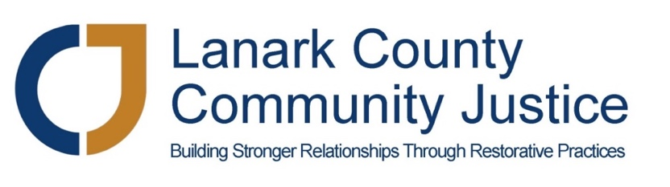

DRAFT Minutes – LCCJ Board Meeting – November 25, 2021

, 2020

Present: Aisha Toor, Chair; Ross Dickson; David Burkett; Carol Anne Deneka; Stephen Graham; Sheri Halladay; Elsie Stresman; Margo Bell; Marilyn Bird; Joellen McHard, Executive Director; and Jamie LeeBreach (Student).

Agenda | Description | Action Items/Responsibility
- Welcome and Preliminaries | Aisha called the meeting to order  Welcomed and thanked our student Jamie-Lee Breach.  The agenda was adopted with the addition of a discussion about a Dec 2021 meeting date.  No conflict of interest was declared.  Board Minutes of Oct 27, 2021 were accepted with changes as discussed.  Issues arising from previous minutes - reviewed  Restorative Moment – was to be Mark  Thank you notes were mailed to volunteers. | Aisha Toor  - Ross and Marilyn will review of our Conflict-of-Interest Guidelines.  - Board members reminded to check the Trillium list.  - Reminder that Carol Anne volunteered to join Finance Committee.  - Dave to review engagement for organizations under $500K but believes we are fine. MCCSS Diversion Program contract may require audited financial statement – Joellen to confirm.  - The review of the Terms of Reference for the Nominations Committee will remain a Standing Item.  - Aisha will send a link to recording of our recent Google docs training session.  - Marilyn will lead the Restorative moment for the next meeting.
- Executive Director’s Report | Joellen presented her report.  Reviewed feedback from Panel Discussion on Restorative Justice Response to Sexualized Violence/Sexual Assault.  Joellen brought the Board’s attention to mandatory online training for facilitators scheduled on 3 Saturdays in Jan 2022 by Restorative Justice on the Rise.org  An Open House to be scheduled in early 2022 will welcome volunteers, media, clients and the public to our new offices and recognize the important donation of the Trillium Foundation.  Moving forward, all participants and guests at events must be documented, double-vaxed and masked, and maintain appropriate social distance.  Stephen mentioned that the new database development is going well.  The Giving Tuesday campaign was delivered and a holiday card was mailed to all volunteers along with a $15 Starbuck’s gift card. | - Aisha and Carol Anne to assist in organizing food for the Open House in early 2022.  - Joellen invited Board members to check out online training by the Trauma Informed Practice Institute.  - The year-end fund raising letter will be stuffed by Jamie-Lee so Mark and Carol Anne may stand down.
- Finance Report | David presented the following documents:  - Balance sheet to Oct 31, 2021  - Profit and Loss to Oct 31, 2021  - Cash flow to Oct 31, 2021  - Finance report from the Treasurer  - Letter of Management from Auditor  Dave reported a healthy cashflow and responded to questions. | - David Burkett and Joellen to confirm if reply is required to Allen Management.  - Joellen to confirm if GIC must be increased by $1,500 to cover increase in overdraft on VISA card
- Human Resources | Aisha Toor  Aisha mentioned there was nothing to report at this time. She announced that Elsie will be focusing on Afghan Resettlement initiative and that Carol Anne will take on the Board Secretary function. | - Aisha will meet with Joellen in December to confirm / discuss any issues that may arise.
- Fund Raising Committee report | Joellen presented the following updates:  - Fund Raising Committee report  - Perth Polar Bear Plunge update  - Fundraising budget update | Joellen McHard  - Confirmed that Lanark County OPP registered from the Polar Plunge.  - Aisha will send Joellen a possible contact from government funding.
- Governance Committee | Stephen Graham  No report or update this month | - Committee may look at By Laws specifically Policies and Procedures re Segregation of Duties if required.
- New Business | Elsie provided an update on the Community Alliance for Refugee Settlement and referred Board Members to their website THECARR2.ca for more information.  The Holiday party will be combined with the Open House scheduled on February 12, 2022
- Next Meeting | Next Board meeting – JANUARY 26, 2022  (no December 2021 meeting is scheduled)
- Closing Round and Adjournment | Motion to adjourn at 7:45pm made by Aisha, seconded by Ross

__________________________________ ______________________________
Aisha Toor, Chair Carol Anne Deneka, Secretary

