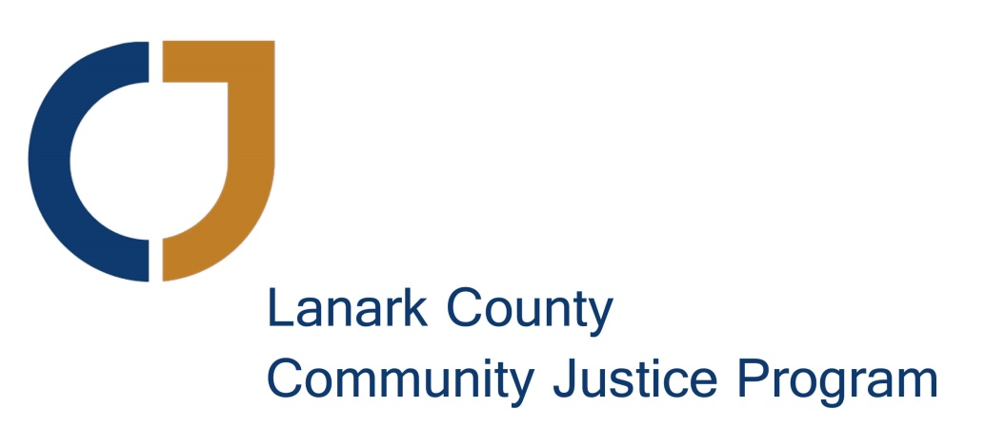

Strategic Plan
2016-2019
(complete with possible action items)

Approved by the Board of Directors
October 15, 2015

Executive Summary:

The Lanark County Community Justice Program (LCCJP) is at an exciting and expansive stage of development. To guide this next stage of growth, the Board of Directors undertook an internal planning process in June of 2015, soliciting input from our staff and volunteers. The Board and staff met under the support of an external facilitator, Toby James, to determine our direction for the next three years. Our values, vision and mission have been redefined to fit our changing role as providers and promoters of restorative practices beyond simply the criminal justice system. We have established new strategic goals to guide our work.

At its core, this Strategic Plan outlines a focused direction for maximizing our effectiveness, providing service to our community, extending our leadership and expanding the implementation of restorative practices. Pre- and post-charge referrals and the resulting community justice forums have been the basis of our organization since our inception and still form an important part of what we do. Over the term of this Strategic Plan we will be expanding more proactively into the community to promote the use of restorative practices and communications in everyday life – in schools, workplaces and other organizations. In addition, we are building on the strengths of our volunteer facilitators to take on more serious referral cases post-sentencing. Our funding model will need to change to allow us to build capacity in a sustainable way.

LCCJP is excited to be at a point in our development to make a bigger impact on our community and show leadership in the area of restorative practices. With experienced staff, a truly committed Board of Directors and a strong core of trained volunteer facilitators, we are well-positioned to implement this Strategic Plan.

Lanark County Community Justice Program Vision, Mission and Values

Our Vision
Our community that embraces restorative practices to repair harm, build community and strengthen relationships.

Our Mission
To provide and promote the community use of restorative practices.

Our Values

- Inclusiveness: Creating safe, respectful spaces where all people can “speak their truths” in an open and honest way.
- Responsibility: People are responsible for their actions and are accountable to others.
- Trust: By building, maintaining and restoring relationships, our community becomes stronger.

Goals and Objectives 2016-2019

Goal | Objectives | Possible Actions
- Provide more restorative justice services.  Many more citizens of Lanark County could be benefiting from community justice forums. | 1.1 Continue to increase pre- and post-charge referrals. | - Work with our court liaison partners to develop a county-wide criminal diversion protocol  - Continue to build relationships with the police services to encourage pre-charge referrals of youth and adults.  - Continue to build relationships with the Crown Attorneys to encourage post-charge referrals of youth and adults.  - Establish regular opportunities for conversations with the police services and the Crown Attorney as a communication link.
 | 1.2 Develop ways to provide restorative practices across the spectrum of criminal justice including post-sentencing and disposition. | - Communicate with the Crown Attorney about the opportunities for post-sentence referrals.  - Provide additional training to more-experienced facilitators with identified skill sets to enable them to handle post-sentencing referrals.
- Promote community use of restorative practices.  Many more citizens of Lanark County could be benefiting from community forums and other restorative practices. | 2.1 Improve community understanding of restorative approaches. | - Develop communications materials that strongly represent our vision.  - Raise the profile of National Restorative Justice Week.  - Upgrade the LCCJP website, including internal and external resources.  - Participate with the OPP Situation Table model and community partners.
 | - Promote the use of restorative practices in Lanark County schools, workplaces, agencies and other organizations. | - Promote training and other interventions in the community; e.g. tenant-landlord issues, caregiver communications, community projects, etc.  - Develop a program to work proactively with the 40 schools and youth centres.  - Make use of the OPP school-bullying toolkit and work with community partners.
3. Build the capacity of LCCJP. | - Provide opportunities for education and growth for facilitators, volunteers, staff and Board members. | - Encourage and facilitate inter-agency meetings as well as meetings with other restorative justice and like-minded organizations.  - Promote training from outside resources for facilitators, volunteers, staff and Board members.
 | - Increase the funding base to allow us to grow our capacity. | - An ideal staffing model includes a full-time Executive Director and a full-time Program Coordinator along with a part-time Administrative Assistant and a part-time Volunteer Coordinator.  - Each staff member requires a dedicated work station and the equipment required to complete their tasks in a professional manner.  - A volunteer bookkeeper and a college 2nd year placement student will provide support to the staff as noted above.  - Secure storage space is required for confidential files and records.  - Develop a 3-year Sustainability Plan.  - Investigate new sources of funding, such as donor campaigns, major grants, corporate sponsorship and fee-for-service training opportunities.  - Fundraising events will supplement other revenue sources (but will be gauged against the effort involved).
 | - Enhance the use of our volunteer resources. | - Develop a committee framework that allows for increased capacity of the organization and engages other skills from the community.  - Assess board and committee structure including size and composition for optimal impact.
 | - Clarify our message and brand so that the community can easily understand what we do. | - Develop a non-justice operating name to be used when identifying programs not involving the police services or the Crown Attorney.  - Website updates need to better reflect our brand and messaging.  - Develop the use of social media to increase our messaging reach.

