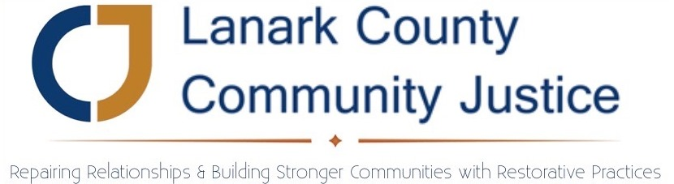

September 26, 2017
Motion:
That the signing officers of Lanark County Community Justice Program Inc. be updated to read “any two of the following, who will be responsible for signing cheques, instruments and agreements and also for establishing credit”:
1. Chair, Murray Long
2. Treasurer, Jennifer Greaves
3. Vice-Chair, Scott Ferguson
4. Secretary, Margo Bell
5. Executive Director, Sarah Bingham

Any and all previous designations of signing officers are hereby rescinded.
- Moved By Murray Long
- Seconded By Jennifer Greaves
- Carried Unanimously.
Motion passed on September 26th, 2017

Murray Long Jennifer Greaves
Board Chair Treasurer

