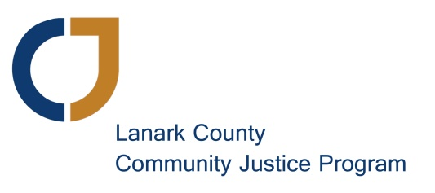
Nominating Committee Report
June 12, 2017

Nominating Committee: Christine Peringer (Past Chair), Sarah Bingham (Executive Director).
If the membership approved the change in our bylaw proposed this evening, LCCJP will have at least seven and a maximum of nine people on the Board of Directors. Four of the current board members are in the midst of their terms:
- Murray Long (Chair)
- Scott Ferguson (Vice-chair)
- Margo Bell (Secretary)
- Linda Rush
This means we have three vacancies to fill as a minimum. LCCJP sent notices seeking candidates for these board vacancies to all LCCJP members and volunteers and others on our mailing list, the Lanark County Planning Council for Children Youth and Families and all its member agencies, the United Way and all of it’s considerable connections, all town councils and other community partners. In addition we posted the notice on our website, Facebook, Twitter and advertised in the four local editions of the EMC.
We were happy to receive four strong applications. The four candidates have been interviewed and reference checks were conducted as outlined in our policies. The following four candidates (in alphabetical order) are nominated to fill the vacancies on the Board of Directors:
- Shannon Forsyth
- Georgia McNally
- Cheryl O’Connor
- Brian Peters (seeking a second three-year term)
Moved by myself, Christine Peringer, and seconded by Murray Long to accept these candidates as members of the Board of Directors of the Lanark County Community Justice Program.
Signed ____________________________________________ Date June 12, 2017
Christine Peringer
Signed ___________________________________________ Date June 12, 2017
Murray Long

