Office Space:
It has been determined by the board that we need office space to meet with clients, meeting space for facilitator meetings and board or committee meetings and training space. We should have set office hours and a presence in the community. The office does not have to be in Perth it can be anywhere in Lanark County. To date we have only viewed space in Perth.

We also regularly access free meeting space in other communities, and we have a list of spaces that need to updated since COVID-19. Our student will update this list.

- 14 Isabella (DR’s offices/clinic kitty corner to hospital). Contact: Shelley Xu.

The building has been recently renovated and is modern, bright and clean. Currently in the building are offices for 5 doctors (soon to be 6), a pharmacy and Bayshore Home Health. The office space we viewed is on the second floor with no elevator, therefore not accessible space. However, there is a treatment room on the ground floor which would be available as well as a small office on Tuesdays, Wednesdays and Thursdays with advance notice.
- 600 sq.ft. for $900/month plus HST = $1017 includes all utilities and internet
- Common areas cleaned – tenant cleans own office space
- Enter the bldg. from parking lot on Isabella – large reception area for bldg. Clients and visitors check in with receptionist who texts for someone to come down to bring them to the office
- Space for rent has a quite large open space as you enter the offices which could be made into an office (with 2 padded dividers) and small waiting area; two offices – one a good size, outside window and bright, second very small but outside window, bathroom and good size storage cupboard for files
- Access to board room for meetings, facilitator meetings and forums at no charge However, currently limited space – 2 large cubicles to come down and open up the space (if we are interested would ask for the cubicle partitions to make the office suggested above). Work will be done within the next year
- Can book the lobby downstairs evenings and weekends for larger groups – has been used for training (CPR)
- Access to kitchen on 2nd floor – fridge, microwave, sink etc. and lounge area – used by staff
- One designated parking spot – balance of staff would use street parking – clients could use parking lot up to a few hours. All doctors have parking at the hospital and walk over – their staff have no problem with street parking, but arrive by 8:30 – may be a concern for us… Street parking on Mary and surrounding streets
- Current tenant leaving the end of June

- Code’s Mill – Herriott Street Contact: John Stewart
The building is older, but with character.
- $975 per month plus HST = $1101.75 for undetermined sq.ft. - includes all utilities and 2 parking spaces - tenant pays internet and phone
- 2 large offices and large storage room/office
  - 1 office large window overlooking park, 2nd office has large opening overlooking the Atrium for air flow, 3rd office/storage has no window – all rooms have ceiling fans
- Space is upstairs, no elevator, therefore not accessible – only accessible space is Atrium on ground floor – privacy concerns
- Common reception area for offices upstairs – other tenants currently are Interval House, Options Youth and one private company
- Common areas are cleaned – tenant cleans their own space
- Common washrooms – no kitchen area
- Access to board room – no charge – would work well for board meetings, but large table so not for forums and too small for facilitator meetings
- Larger space available for facilitator meetings 1 x month at NC, would discuss rental rate if needed more frequently
- Available the end of the month

- Second option: rent 2 offices and not 3rd with no window @ $675/month plus HST = $762.75 per month – everything else the same…

- St. Paul’s United Church – 25 Gore St. W.
Contacts: Office Admin: Joanne Lucas, Project Planner: Reid Kilborn
St. Paul’s is looking at repurposing their Sunday School Rooms (2 rooms) and Nursery (1 room). They are looking at targeting child and youth serving agencies in these spaces. They currently have a Children Resources on Wheels (CROW) daycare in the basement of the wing they are offering space. It is an old building, not much natural light nor air circulation.
- Large room11 x 21 (240 sq ft) and smaller room off it is 11 x 12 (159 sq.ft.) with accessible bathroom. Staff could access kitchen to put lunch in the refrigerator or store something for a meeting
- Joanne was unable to provide pricing – thought around $800 per month would be possible – she is checking with rental committee
- Access to a large meeting and training space and large kitchen as well as a number of other spaces – sheet attached with fee structure, however if we were tenants Joanne believed we could negotiate rental fees
- It is an old building without much light or air circulation.

- Second option: Two good size rooms in the Tower with shared bathroom with janitor supplies. Currently renting at $500 during Covid – Joanne thought they would rent to us… Not accessible. Reported it was cold in the winter (current occupant had large space heater) and hot in the summer – no air conditioning, nor ceiling fan

Photos/Links to spaces described above:
14 Isabella Street
https://www.kijiji.ca/v-commercial-office-space/ottawa/medical-clinic-office-space-for-rent-in-perth-ontario/1558756085

Codes Mill

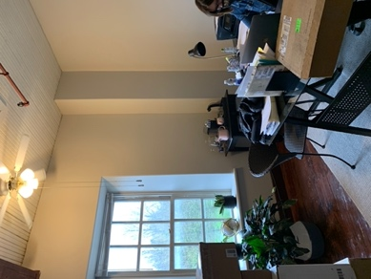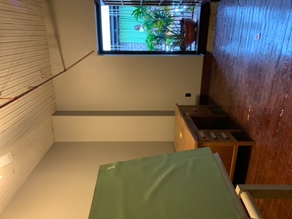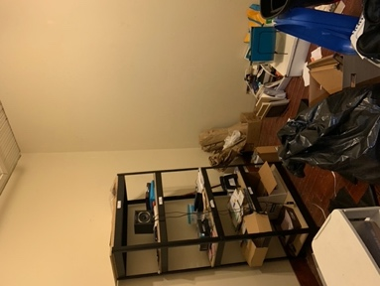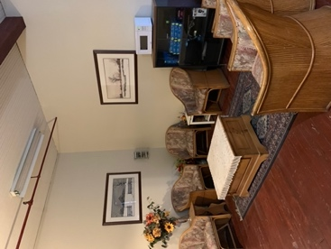
Outside window Atrium opening Storage Area/office Common waiting area

St. Paul’s United Church

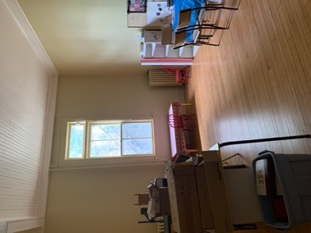 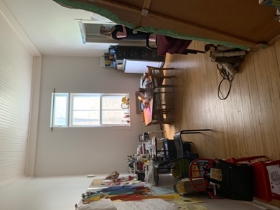 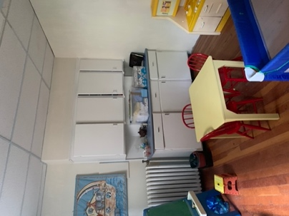 Basement Area

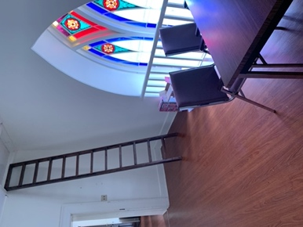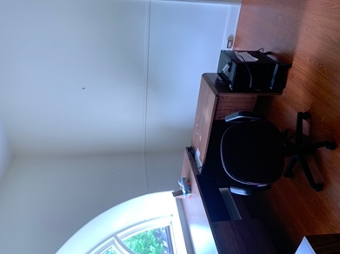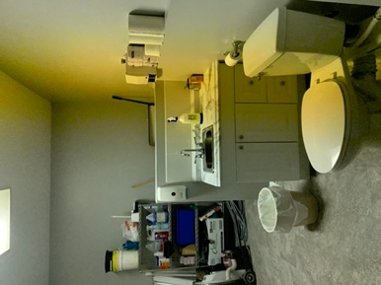
Tower area – not accessible and concern regarding air quality and temperature

Other Spaces in Perth:
1) The Factory – Sunset Blvd. Contact: Jane
Currently only Suite 42 available – 1047 sq.ft. – 4 large bright offices plus reception – will not divide
$2181 plus HST per month ($1745 for office space and $5 sq.ft for common areas = $436)
Common areas – board room, kitchen/staff room, large meeting room

Jane kept our name and number in case anything becomes available – for example 506 sq.ft. would be $725 plus common area at $208 = $933 plus HST = $1054.08/mos.

2) 23B Wilson St. W. - $1750 plus HST = per month = $1977.50 – large office space
Direct entrance to offices from street

3) 29 Herriott St. – house across from the library – door to the left
Two small offices, connected to each other – 4 x 6 and second 12 x 16 plus bathroom
No meeting rooms, 1 parking space
$1050 plus HST/ month = $1186.50

4) 10E Herriott St. – current space Contacts: Dave Ireton & Andrew Wilson
FCSLLG lowered our rent during 30 in 30 and have not increased – currently paying $200 /month
Our lease agreement had been $792/month
New owners - $1170 plus HST for 775 sq.ft. = $1322.10 per month
Space has own entrance from parking lot – 2 designated parking spaces – accessible office space
No access to meeting rooms

