Office/Storage Space Search
June 16th, 2021
Progress Report
We are continuing to search for office/storage space. I sent an email to the Child and Youth Service Collaborative about our search for space.
- Herriott Street: We have not received an eviction notice from the current landlords but we did receive verbal request that we are out by July 31st. They offered 10F (10 offices), for $1170/mo until Jan 1, 2022. They offered 10D, with cubicles for $792/mo. I asked about one office at current address 10E and they will get back to me as they will speak with the prospective tenants. Any office would be $22/sqft all inclusive – the price has gone up from $18/sqft since we last spoke.
I sent a message to the facilities manager at FCSLL&G to see if they have a temporary space that we could have for a while, in case we do not find a suitable alternate space. They do not have anything available.
- YAK – Youth Action Kommittee – there is a shared space available in a large room to store files that would have internet included for $300/mo. $25/hr meeting space upstairs.
- Town of Perth: SEE MORE DETAILED INFO BELOW. I reached out to the Town of Perth about 1881 Rogers Road, as Sheri and I noticed a large ad in the Perth Courier about a tender for this space (used to be Perth Police, then TR Leger) It currently houses the fire department, FireDawgs, a CrossFit Centre, The Table has storage space, a skating rink, and plans for a basketball court. It is a large office space for $4,500 month. I spoke with Shannon Baillon, Director of Community Services at the town and they are willing to flex on rates for charities. I followed up by reaching out to YAK who have been considering other spaces and who also receive $30,000 a year from the town to pay for rent, to see if they were interested in the space. Rachel Roth from YAK, has reached out to her executive. I also reached out to Ramsay Hart, at the Table Community Food Foundation, as he was possibly looking for one or two office spaces if the price was right. Rachel, Ramsay and I (and others?), will go and view the space together and then engage in inter-agency discussion about how we would like to proceed.
Contact Information:
Shannon Baillon
Director of Community Services
The Corporation of the Town of Perth
80 Gore Street East
Perth, Ontario, K7H-1H9
Tel:613-267-3311x2227
Email: sbaillon@perth.ca
Fax: 613-267-5635
Web: www.perth.ca

Thank you for your Expression of Interest to lease space at 1881 Rogers Road
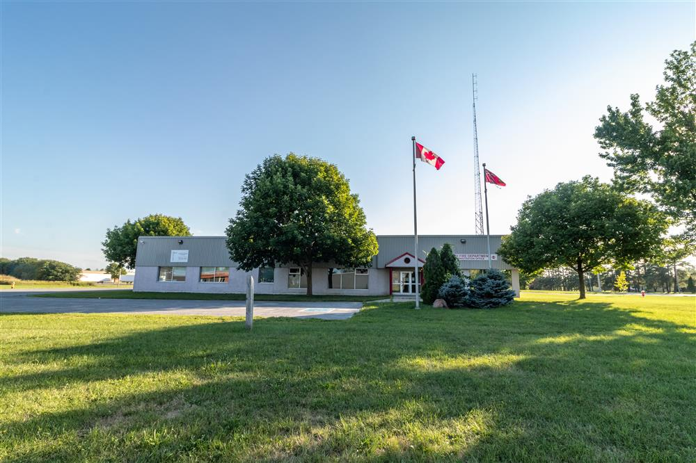
The Town building at 1881 Rogers Road, is currently home to the Perth Fire Department and one other tenant. The third tenant, the TR Leger School, has given notice that they will be leaving the space as of 31 Aug, 2021. Please fill out the questions below to describe your desire to lease the space that TR Leger previously occupied. Contact Shannon Baillon at 613-267-3311 Ext 2221 to arrange for a site visit. Submissions must be received by 4:30 pm on 3 June, 2021 and will then be assessed with a recommendation to Council in June of 2021.
The space available for lease is approximately 3000 ft² consisting of the following:
- Shared entrance (with Fire department) shown in photo above
- Shared Lobby (with Fire department) 250 ft²
- One unisex accessible single washroom
- One small 2 piece washroom
- Three small storage rooms totalling 280 ft²
- Three medium sized offices totalling 1280 ft²
- One large room 826 ft²
- Hallway 315 ft²
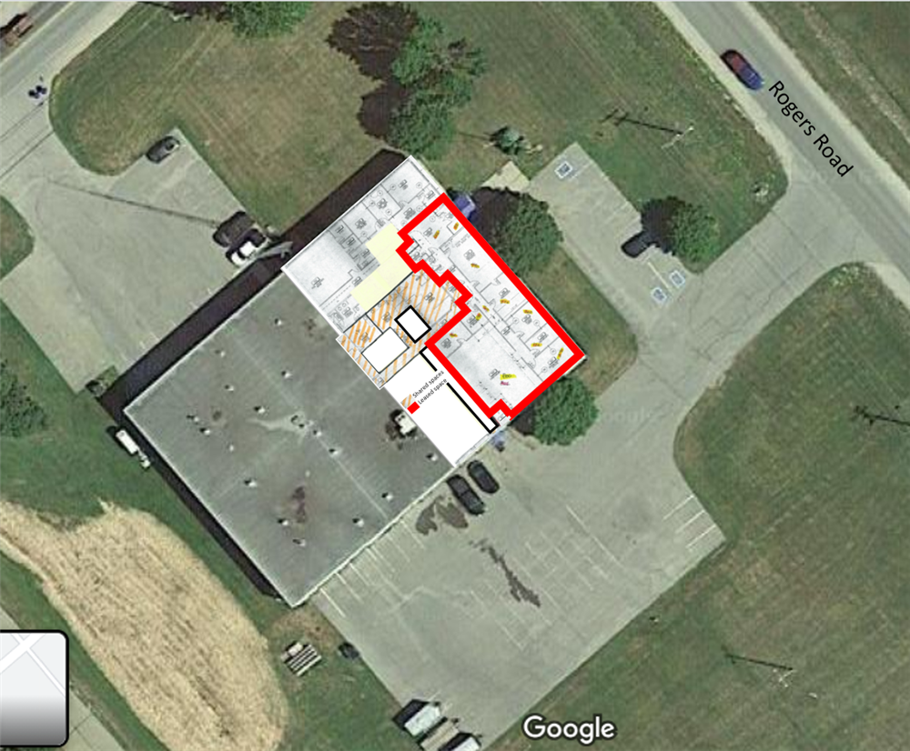
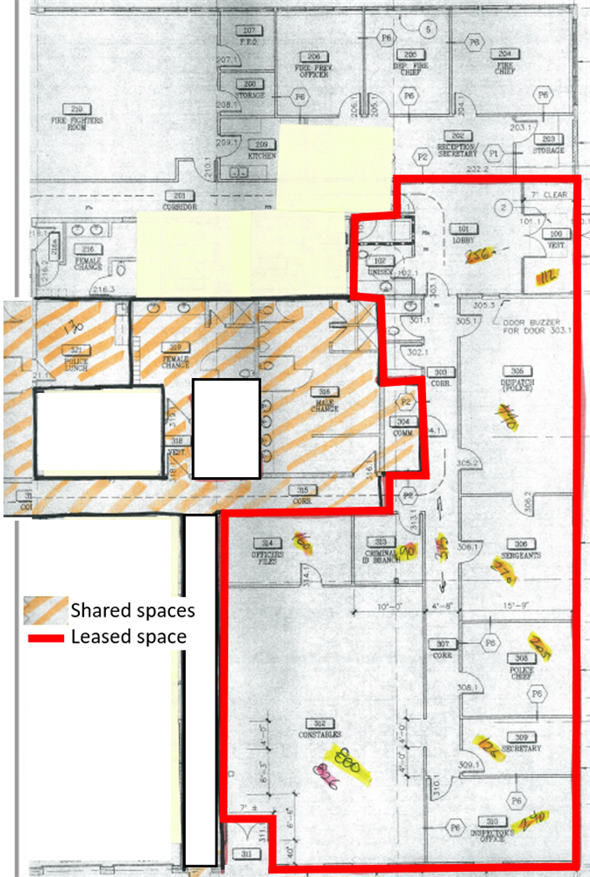
-----------------------------------------------------------------------------------
Tennant must provide:
- cleaning of all areas regularly, except shared spaces
- cleaning supplies/garbage bags
- furniture
- any required IT services
-----------------------------------------------------------------------------------
The Town of Perth will provide:
- Garbage removal from exterior of site
- Cleaning of shared spaces
- Grass cutting and maintenance of grounds
- Utilities including water
- Sufficient air conditioning
- 20 parking spaces
- Regulatory government inspections as required
---------------------------------------------------------------------------------------
If desired, the following shared access may be included:
- Male washroom - 2 toilets (1 accessible), 2 urinals, 2 showers, 4 sinks - 400 ft²
- Female washroom - 1 toilet accessible, 1 shower, 2 sinks - 250 ft²
- Kitchen/Eating area 175 ft²

