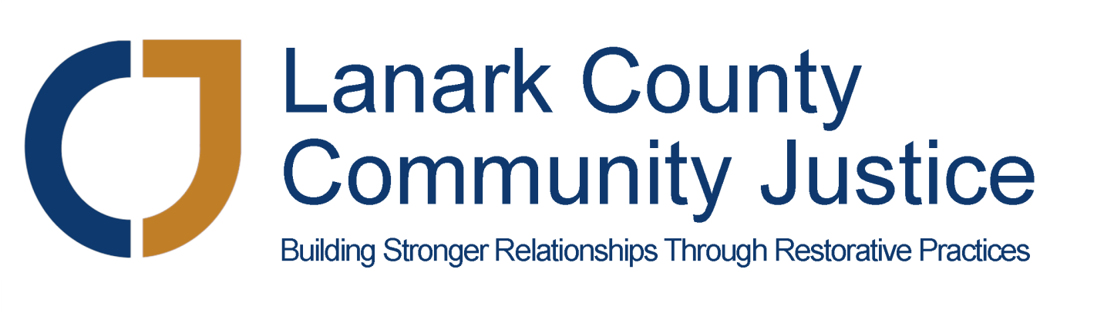
Placement Student Report to the Board April 2018

I would like to open my first report to the Board by thanking all of you for this opportunity to complete my BSW placement at LCCJ. I am very excited to be learning about restorative justice, and how it is creating a better response to conflict, as well as proactively strengthening relationships and communities.

The energy, enthusiasm, and expertise of LCCJ staff, volunteers, and the larger community, really does create an ideal environment for observing and developing the skills to make me a successful social worker. I have already been given a tremendous amount of information and experiences to process since starting on April 9. I have learned much about LCCJ values and services, general restorative justice principles and practices, and about the prolific collaborative work happening in the area.

Some of my activities so far include:

- Attending various meetings such as the Youth Homelessness Collective Impact Initiative, HSJCC Youth at Risk subcommittee, the Planning Council’s Social Issues work group, and Smiths Falls Youth Campus planning session.
- Provincial training on accessibility.
- Review of webinar on restorative justice principles.
- Receiving LCCJ and MAG training on confidentiality and restorative justice.
- Connecting with LCCJ staff to learn about their programs/projects, and coordinate upcoming job shadowing and program support work.
- Participating in webinar and discussion on Self-Injury.

Prepared By: Francis Wooby

