Quarterly Program coordinators report- August 19, 2020
Highlights April 2020
- Huge learning curve-online zoom platform
- Discussions with Andrea Halliday (family and children worker) providing on-line Triple-P Parenting for Teens
- Creatively closing 8 open files
Highlights May 2020
- Online Coaching series with Molly Rowan Leach- founder of Restorative Justice on the Rise. 6 week session, 4 hours a week.
- 2 hours of theory, 2 hours of practice.( see next page)
- Online Triple-P and restorative practices preparing to Launch for June
- Zoom facilitator meeting
- Regional justice online coordinators zoom meeting
- Online consent and information tips formed
- Micro soft updates on computers
- Data base with much appreciated help from Steve Graham, is in the works!
- Courts are still not open
Highlights June 2020
- Telephone conversations with crown regarding youth docket
- Lake 88 interview over phone regarding Triple-P, commencing June 16
- Talks regarding golf tournament
- Eastern training for C-75 with MCCSS
This training session will allow participants to better understand and contextualize: The principles of the YCJA
- The amendments to the YCJA under former Bill C-75
- The reasoning and objectives behind these amendments
- Administration of justice offences
- Diversion methods
- Bail and sentencing principles and conditions
- First online Forum

May highlights:
- 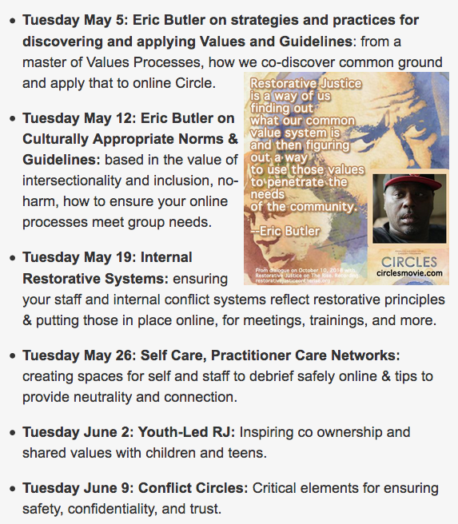
Respectfully

Sheri.

