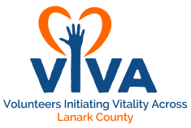

VIVA Training Agenda

Date
8:30 to 9:00 | Registration and Reception

Date
9:00 to 9:30 | Continental Breakfast
9:30 to 10:30 | Welcome and Housekeeping  Introduce Facilitators and Trainers  Ice Breakers  Break in to Groups (2- 4 depending on how many volunteers we have)
10:30 to 12:30 | Confidentiality/Privacy Training  May I Help You Accessibility Training  Customer Service Training
12:30 to 1:00 | Lunch
1:00 to 3:00 | Appreciative Inquiry
3:00 to 3:30 | Wrap Up and Questions
3:30 to 4:00 | Survey

